Hotel Room Booking System
Project: Grand Stay Hotel | Technology: HTML, CSS, JavaScript (localStorage)

Aim
To develop an online hotel room booking system where guests can check availability, book rooms and admins can manage rooms and bookings.

Algorithm
- Start: load rooms and bookings from localStorage.
- User logs in as guest or admin.
- Guest selects check-in, check-out dates and room type.
- Check availability: a room is free if no existing booking overlaps the selected dates.
- Calculate total = nights × room price; show updated total.
- Confirm booking, save it and generate a booking summary.
- Admin adds/edits rooms and views or cancels bookings. Stop.

Result
The Hotel Room Booking System was implemented successfully using HTML, CSS and JavaScript. All modules (login, role-based pages, data entry, search/booking and admin management) work correctly in the browser, and data persists using localStorage.

Implementation (Output Screenshots)
Home page
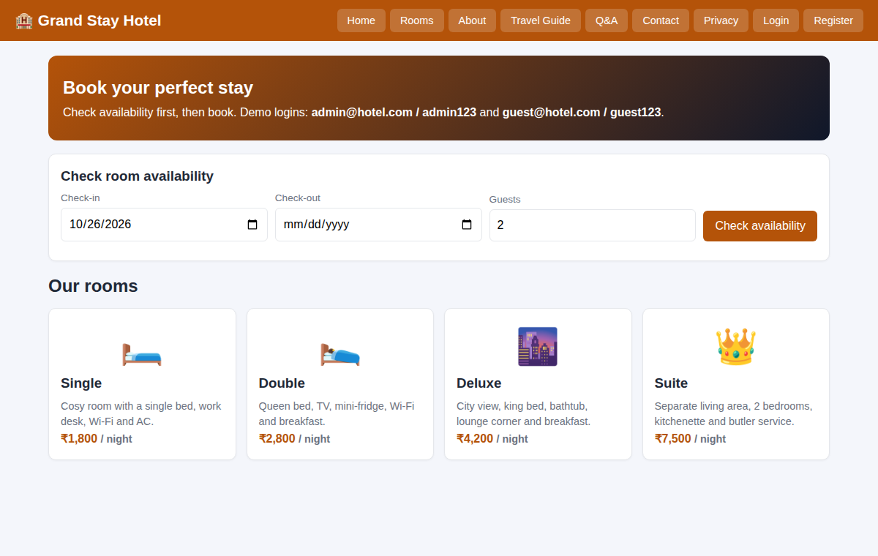
After login (admin / dashboard)
